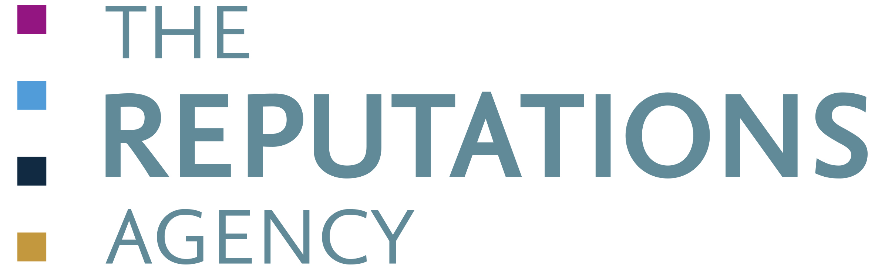
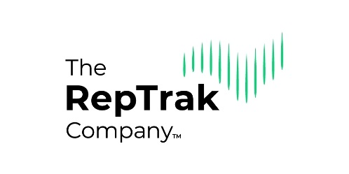

Ireland RepTrak® 2021 Order Form

How to order an Ireland RepTrak® 2021 report
To order a tailored copy of the Ireland RepTrak® 2021 report for your organisation please complete and post or email this RepTrak® Report Order Form to: Ms Marna Harmey, Senior Client Manager, Reputation Management Division, The Reputations Agency,
25 Merrion Square N, Dublin 2. Email: marna@thereputationsagency.ie, Phone + 353 1 661 8915 or Mobile: +353 86 356 5557.
Early Bird Offer
Reports ordered prior to Friday 27th November 2020 attract a significant discount.

Ireland RepTrak® 2021 Report Fees
 | Early Bird Offer Report Fee For bookings and PO’s received by Friday 27th November 2020 | Standard Report Fee For bookings &/or PO’s received after Friday 27th November 2020
Ireland RepTrak® 2021 Pulse report  (includes one benchmark/competitor of your choice) | €15,000 | €19,500
Additional Pulse benchmarks (price per benchmark) | €4,000 | €4,500
Ireland RepTrak® 2021 DeepDive report*  (includes one benchmark/competitor of your choice) | €26,500 | €32,000
Additional DeepDive benchmarks (price per benchmark) | €6,000 | €6,500
Up to three customised attribute questions can be added to your Pulse or DeepDive report for a fee of €750 per question.
*The Ireland RepTrak® 2021 DeepDive report will give the deepest actionable insight into your reputation and is highly recommended.

RepTrak Continuous Tracking (One-year Subscription)

RepTrak Continuous Tracking (One-year Subscription) |  | Fee
Year-round reputation tracking against your chosen benchmark in your chosen market.  Delivered via four quarterly PowerPoint reports & senior advice |  | €70,000 per annum  (includes 1 benchmark of your choice) *
Additional benchmark (price per benchmark) |  | €20,000 p.a.
Additional market/country (price per market) |  | €45,000 p.a.
Additional monthly high-level update |  | €8,000 p.a.
*Further discounts available for multi-year contracts

Reputation Leaders Network (RLN)
 |  | Fee
All organisations who register for a RepTrak® report automatically become members of our Ireland Reputation Leaders Network – an Irish network of senior reputation experts. |  | Included with any order

All prices are exclusive of VAT @ current rate of 21%. All invoices payment due within 30 days.

RepTrak Pulse and DeepDive reports: An invoice will be issued for the first 50% on registration. The remaining 50% will be invoiced upon receipt of the report.

An annual subscription to RepTrak Continuous Tracking can be paid in three instalments over one year. An invoice will be issued for the first 50% upon registration, followed by two instalments of 25% at the end of the second and third quarters following registration.

Ireland RepTrak® 2021 Report Order Form

Mr / Mrs / Ms / Dr | Click or tap here to enter text.
First Name | Click or tap here to enter text.
Surname | Click or tap here to enter text.
Title | Click or tap here to enter text.
Organisation | Click or tap here to enter text.
Address | Click or tap here to enter text.
Phone | Click or tap here to enter text.
Email | Click or tap here to enter text.

RepTrak® Report | Please tick which report you wish to order
Ireland RepTrak® 2021 Pulse report | ☐
Ireland RepTrak® 2021 DeepDive report | ☐
RepTrak Continuous Tracking (One-year subscription, four quarterly reports) | ☐
Please specify Ireland or other market | ☐
Please specify any additional markets required | ☐
Additional monthly high-level update | ☐

RepTrak® Reports and Subscriptions – specify benchmarks | Please list your Company/Organisation and benchmarks/competitors you wish to include
Main Client Company/Organisation | Click or tap here to enter text.
First Benchmark/Competitor (fee included in the price of your order) | Click or tap here to enter text.
Second Benchmark/Competitor | Click or tap here to enter text.
Third Benchmark/Competitor | Click or tap here to enter text.
Fourth Benchmark/Competitor | Click or tap here to enter text.
Fifth Benchmark/Competitor | Click or tap here to enter text.

Purchasing Department |  | Accounts Department
Name | Click or tap here to enter text. | Name | Click or tap here to enter text.
Phone | Click or tap here to enter text. | Phone | Click or tap here to enter text.
Email | Click or tap here to enter text. | Email | Click or tap here to enter text.

Purchase Orders (PO’s): Please indicate whether your organisation requires a Purchase Order for invoicing: ☐YES / ☐NO
- Invoicing Schedule - Early Bird Offer Report Fee for bookings & PO’s received by 27th November 2020.
- RepTrak Pulse and DeepDive reports: An invoice will be issued for the first 50% upon registration. The remaining 50% will be invoiced upon receipt of the report. Invoice payments due within 30 days.

RepTrak Continuous Tracking (one-year subscription): An invoice will be issued for the first 50% upon registration, followed by two instalments of 25% each at the end of the second and third quarters following registration.

Invoice payments due within 30 days. Please sign to accept these conditions.

Authorised signature: Click or tap here to enter text. | Date: Click or tap here to enter text.
Please send the completed form to:
Ms Marna Harmey, Senior Client Manager, Reputation Management Division, The Reputations Agency,
25 Merrion Square, Dublin 2. Email: marna@thereputationsagency.ie or Mobile: +353 86 356 5557 or Phone + 353 1 661 8915.

